Holiday Candy Gram
Fundraiser- Student Council

Erin Godwin 2015

Dear Parents,

This year we are doing something special to help the students at
CIS will celebrate the holidays. Starting December 7, 2016, we will be selling Candy Grams that will be delivered to the classrooms on December 14, 2016. Each Candy
Gram will include a candy cane and a special treat. Parents and family members can purchase Candy Grams for their children and students can purchase them for their friends and teachers! Each Candy Gram is $1 and you may purchase as many as you like. The student will receive an order form and you will have until the
deadline to purchase will be December 13, 2016 to decide whom you and your student would like to send a Candy Gram to. Please be sure to print neatly on your order form and send payment with the order form in an envelope.

Happy Holidays! On Behalf of Student Council

Return completes Candy Gram and money to any of the following teachers: Mrs. Alvarez or Mrs. Espinoza

Please send home extra Candy Grams with my child.

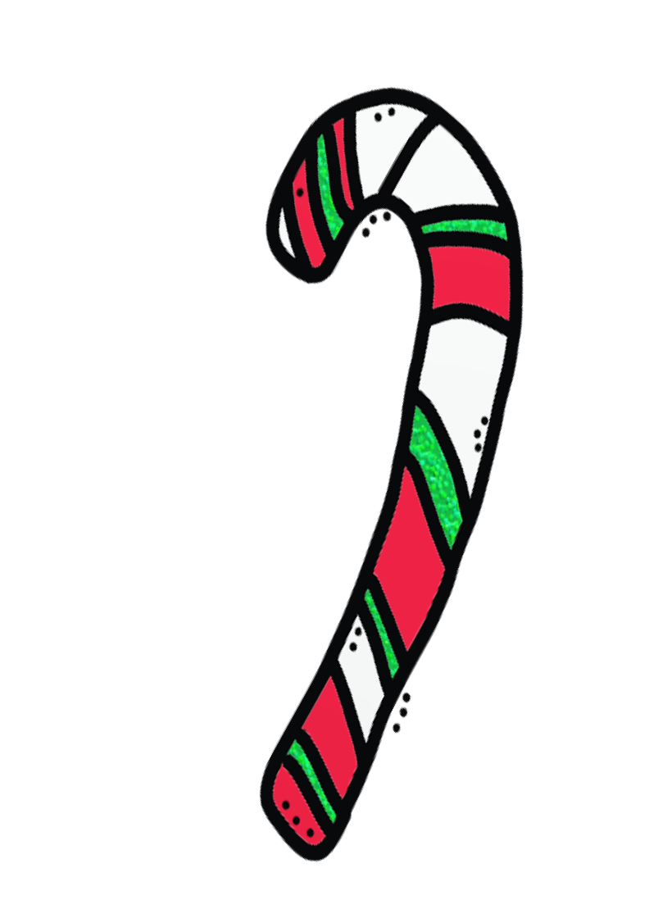
Holiday Candy Gram

To:

7th Period Teacher:
From:
Message:

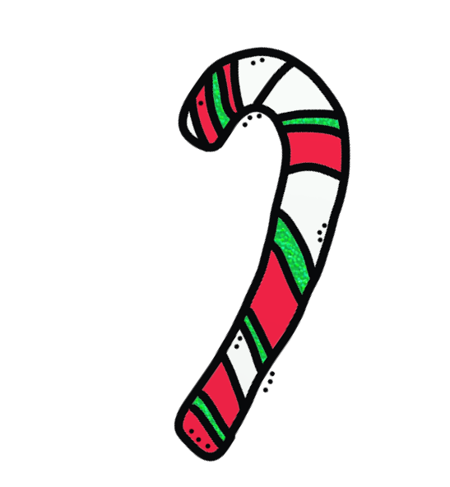
Holiday Candy Gram
To:

7th Period Teacher: From:
Message:

